Student Name: Azamat Salamatov

Professor Cleveland

COMP 3324 - 1

Week 4 – Lab 3 – Web of Trust - WOT

February 28, 2023,

Web of Trust – WOT

Contents

Testing WOT 1

My Summary on WOT: 2

# Testing WOT

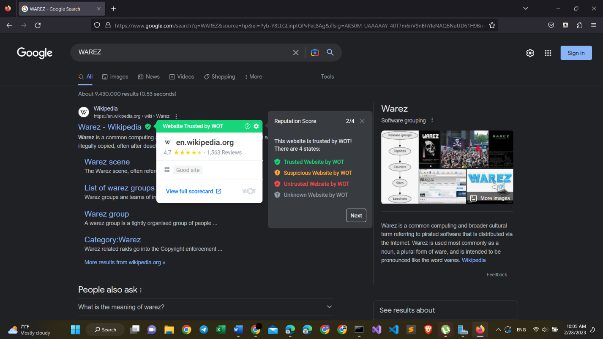

Here is the information of the updated WOT,

* Green sites are trusted
* Yellow: suspicious
* Red: untrusted
* Grey: Unknown

So, Wikipedia.org is trusted and is GREEN

Now, let’s try to open WAREZ.COM:

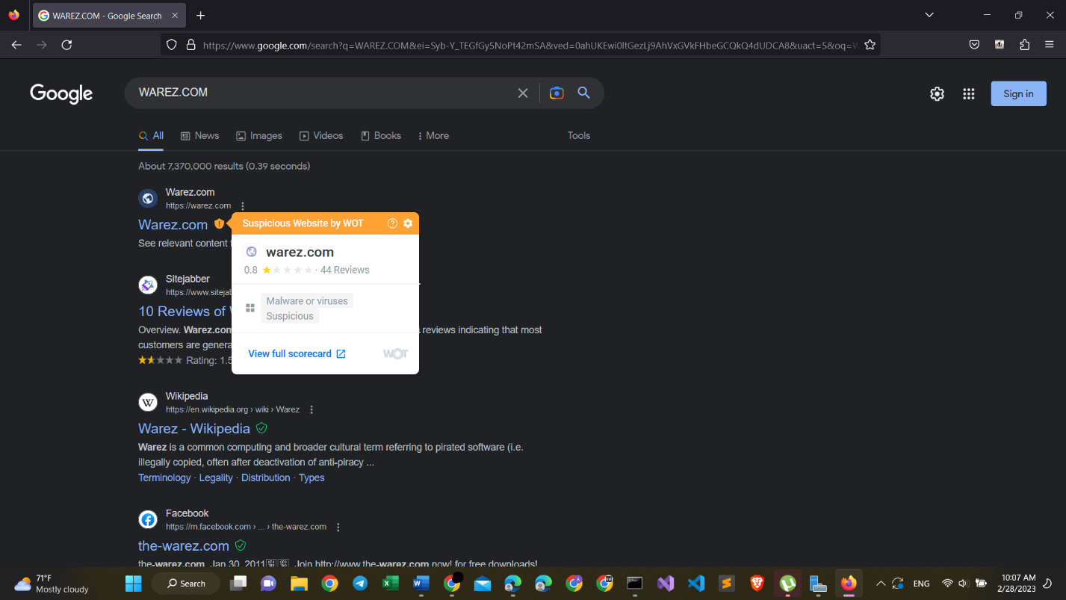

Here we see, that warez.com is suspicious site by WOT. It is Yellow here

# My Summary on WOT:

* This extension is pretty useful, when trying to surf over the internet. It will show some risky sites
* This extension WOT, works pretty well and identifies suspicious sites. For example, warex.com is suspicious, and has a review of 0.8 out of 5.0.
* It has malware of viruses.
* This shows us that WOT works well.